# **Practical – 5**

**AIM: Draw Activity diagram for selected application.**

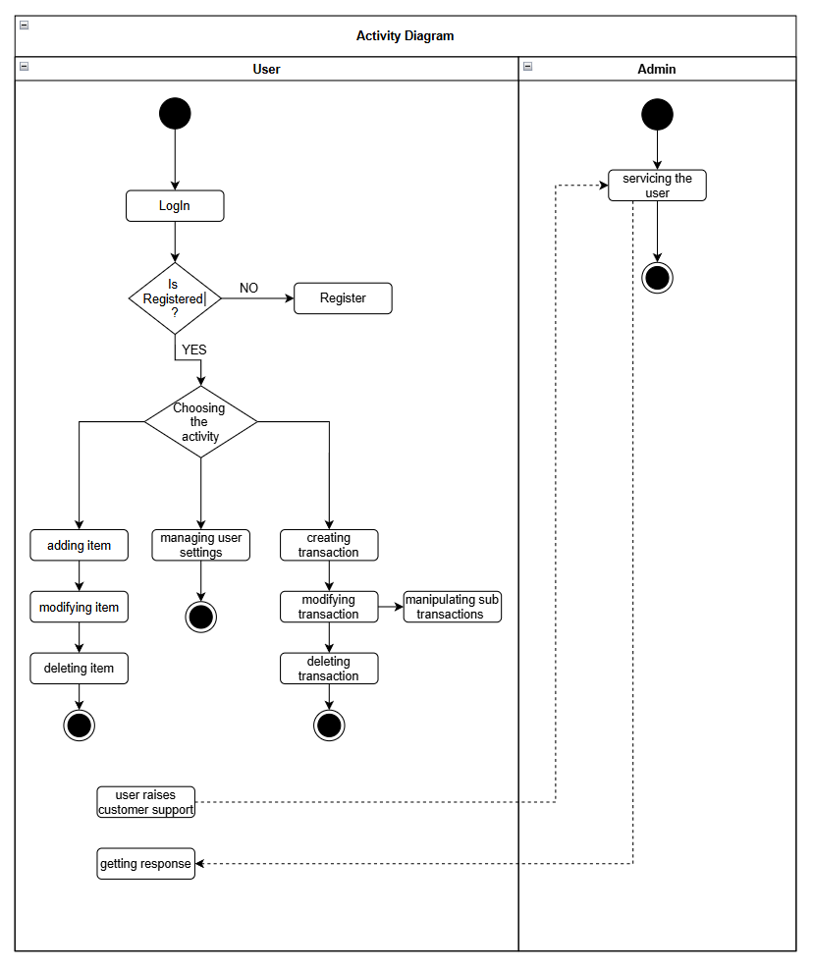**Activity Diagram:**